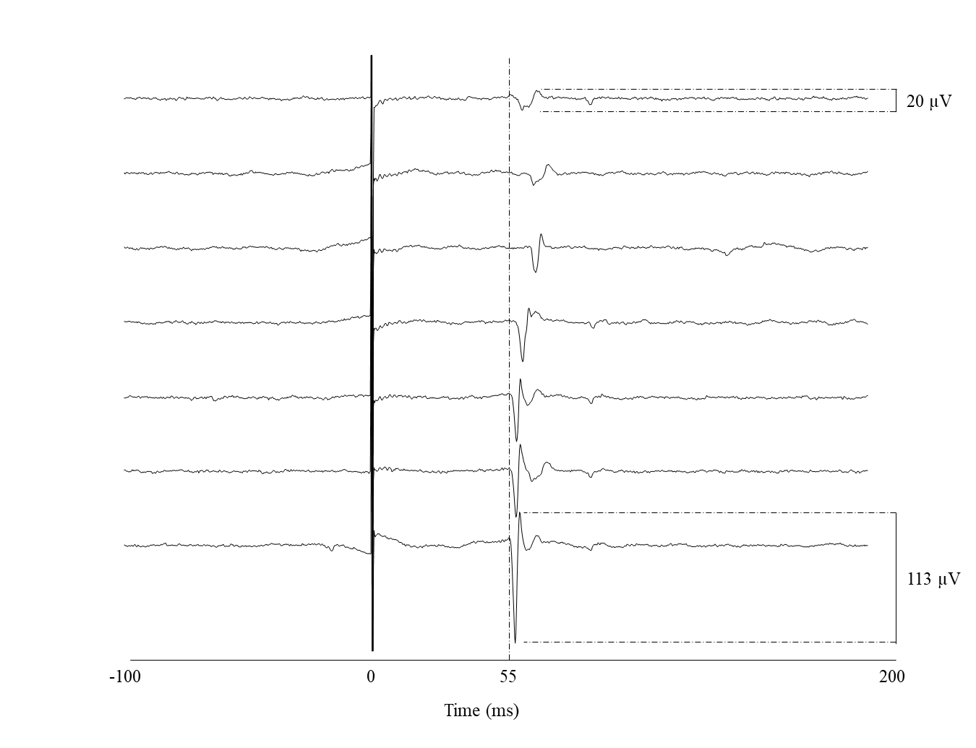**Suppl. Figure 1.** Example MEP traces ranging from 20 µV to 113 µV. Visual inspection was based on both the waveform profile and latency relative to larger, more robust MEPs. This figure illustrates the criteria used to identify valid MEPs near the 20 µV threshold.